## Game Documentation

The goal of the game is to keep Spaceship alive in Asteroid field.

Player can destroy Asteroids by Spaceship’s laser canon.

Player's spaceship is always placed at the bottom of the screen and moves to the sides.

When Asteroid hits Spaceship game is ended.

## Game Elements

### Spaceship

Player Controlled actor

Blueprint Properties:

* Forward Speed[m/s] – Speed of environment particles which are moving from top to the bottom of the screen
* Horizontal Speed[m/s] – Speed of spaceship movement to the sides.
* Shooting Speed[bullets/s] – Spaceship shooting frequency per one second.
* Bullet Class – Bullet actor class which are spawned by spaceship.
* Horizontal Range[m] – Range of spaceship movement to the sides.

### Bullet

Actor spawned by Spaceship. Can destroy Asteroid

Blueprint Properties:

* Bullet Speed [m/s] – Forward speed of bullet actor
* Bullet Lifetime [s] – Size of actor life

### Asteroid

This actor can destroy Spaceship.

Or can be destroyed by Bullet

Blueprint Properties:

* Velocity (Min/Max) [m/s] – Initial velocity range
* (Min/Max) Scale – Initial Scale range
* Points for Destroy – Player earned points for Asteroid destroy
* Asteroid Lifetime [s] - Size of actor life
* After Lifetime [s] – Time to destroy actor after bullet hit

### Spawner

It spawns Asteroid actor.

Blueprint Properties:

* Asteroid Class[1-6] – Asteroid Actors classes which are spawned by Spawners

### Asteroids Invaders Game Mode

Game Mode handles game logic

Blueprint Properties:

* Appearance Frequency[1/s] – Spawning Asteroids frequency per second
* Appearance Frequency Increment[1/s] – Spawning Asteroids frequency incrementation speed.

### Spaceship Player Controller

Game Mode handles Player Input

Blueprint Properties:

* Lose Screen Class – Widget which is showed on the end of the game.

### Destroy Points Widget

This widget is assigned to Asteroid actor and it is played during asteroid destroying.

### End Game Screen Widget

This Widget is added to screen when the Spaceship is destroyed.

### End Game Screen Widget

This Widget is for main menu control.

## Scene Settings

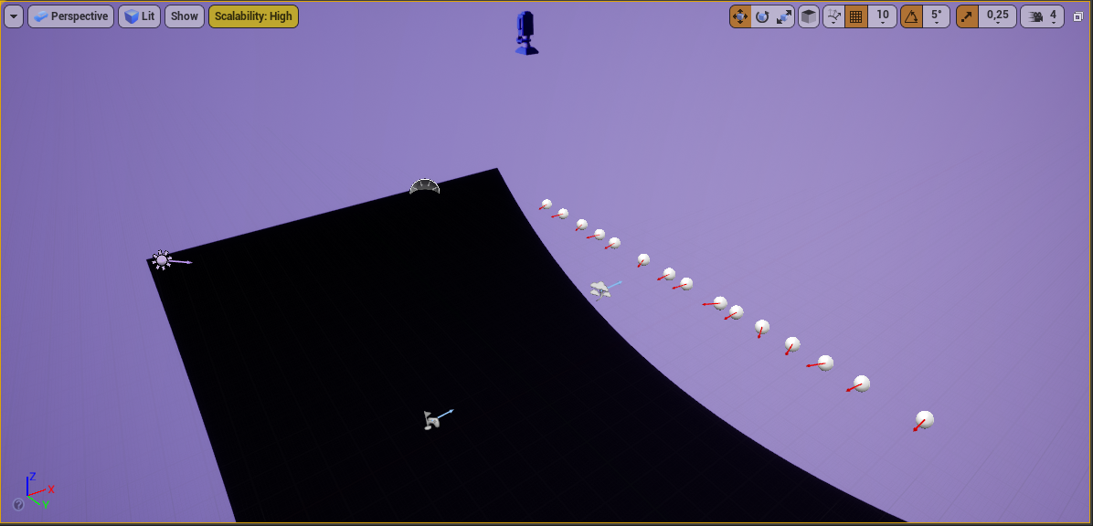

Player Top-down View Camera

Spawners

Background

Player Start